DSA0502 – QUERY PROCESSING FOR DATA SCIENCE
LAB PROGRAMS
NAME: B KIRTHANAA REG. NO - 192324244
5.Write a Pandas program to create a bar plot of the trading volume of Alphabet Inc. stock between two specific dates.
AIM:
To create a bar chart showing the trading volume of Alphabet Inc. stock between two specific dates using Pandas and Matplotlib.
CODE:
import pandas as pd
import matplotlib.pyplot as plt

# Read dataset
stock = pd.read_csv("Alphabet.csv")

# Convert Date column
stock["Date"] = pd.to_datetime(stock["Date"])

# Select data between two dates
data = stock[(stock["Date"] >= "2024-01-01") &
(stock["Date"] <= "2024-01-05")]

# Bar Plot
plt.figure(figsize=(6,4))
plt.bar(data["Date"].dt.strftime("%d-%m"), data["Volume"])
plt.title("Alphabet Inc. Trading Volume")
plt.xlabel("Date")
plt.ylabel("Volume")
plt.show()
OUTPUT:
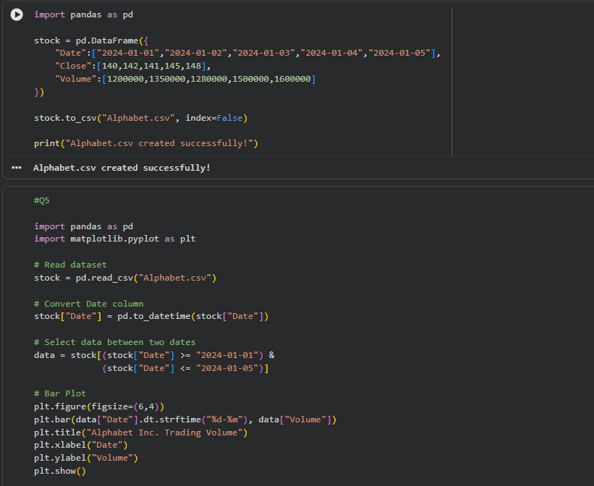
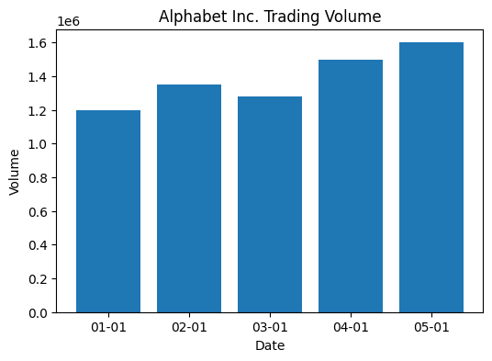
6.Write a Pandas program to create a scatter plot of the trading volume/stock prices of Alphabet Inc. stock between two specific dates.
AIM:
To create a scatter plot showing the relationship between the trading volume and closing stock prices of Alphabet Inc. using Pandas and Matplotlib.

CODE:
import pandas as pd
import matplotlib.pyplot as plt

# Read dataset
stock = pd.read_csv("Alphabet.csv")

# Convert Date column
stock["Date"] = pd.to_datetime(stock["Date"])

# Select data between two dates
data = stock[(stock["Date"] >= "2024-01-01") &
(stock["Date"] <= "2024-01-05")]

# Scatter Plot
plt.figure(figsize=(6,4))
plt.scatter(data["Volume"], data["Close"])
plt.title("Trading Volume vs Stock Price")
plt.xlabel("Trading Volume")
plt.ylabel("Closing Price")
plt.show()

OUTPUT:
